**Complain Redresssal System**

ABC Telecom Ltd. - telecommunication company.

providing diffrent types services like landline, mobile phone and fiber optics

service.

**Admin:**

admin will deside who is customer or enginner or manager

**Customer:**

login/logout

raise the complain

track the complain status

check the history

**Manager:**

login/logout

check all new complain

assign complains to diffrent engineers according to pincode

**Engineer:**

login/logput

check newly assigned tickets

try to resolve from center side if resolved then update the status

else assign to some field engineers to resolve. According to that he will update the status.

User login

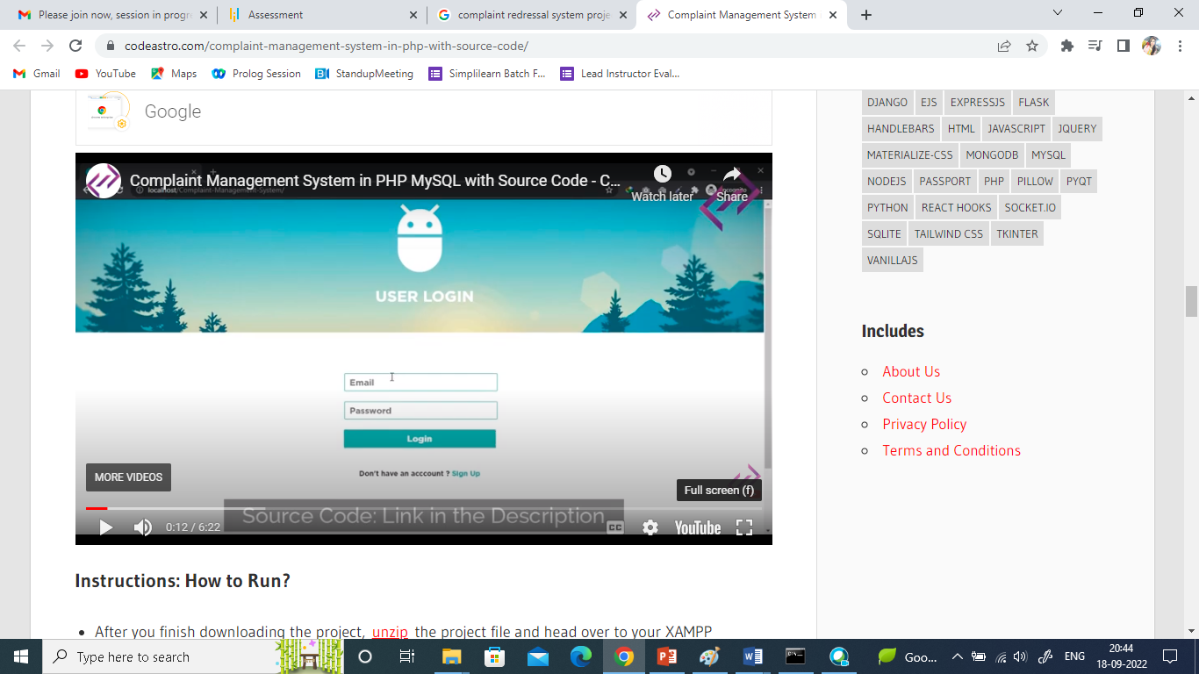

After Successful Login



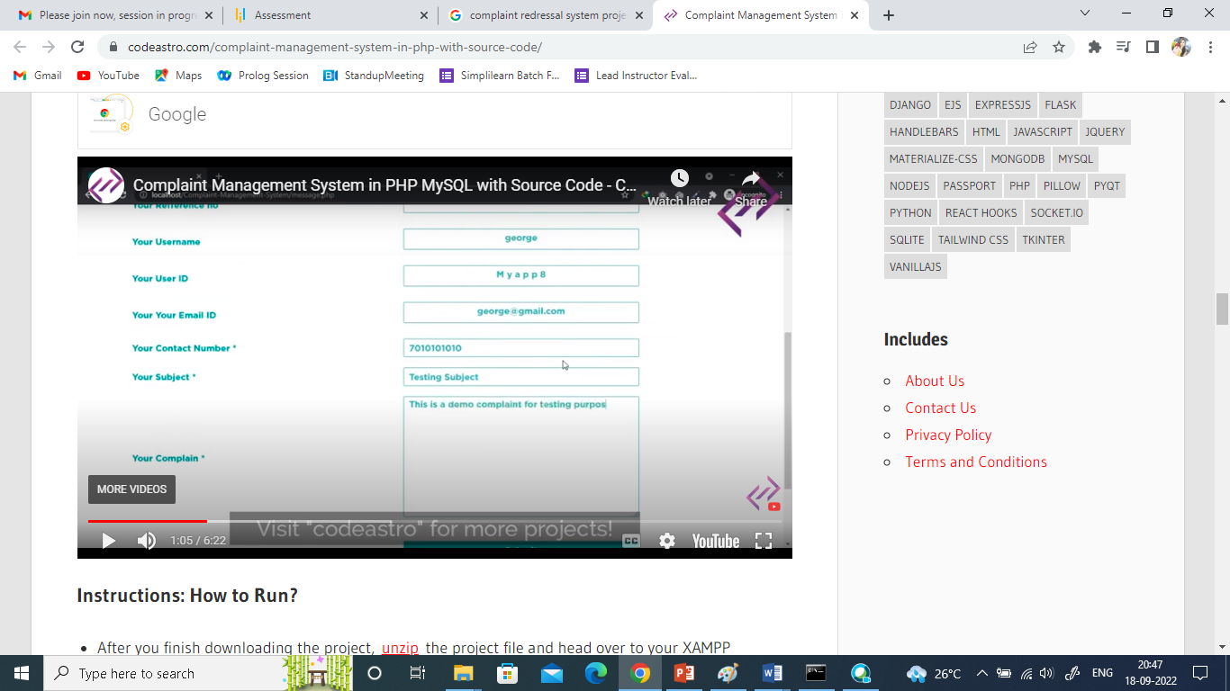Click on Add Complain

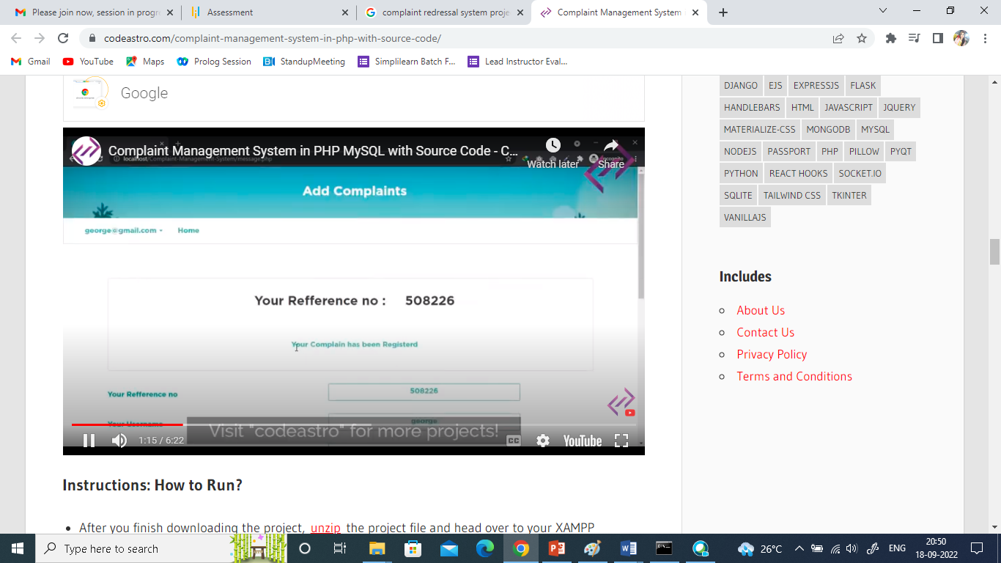

Click on Logout to get back to Login Screen

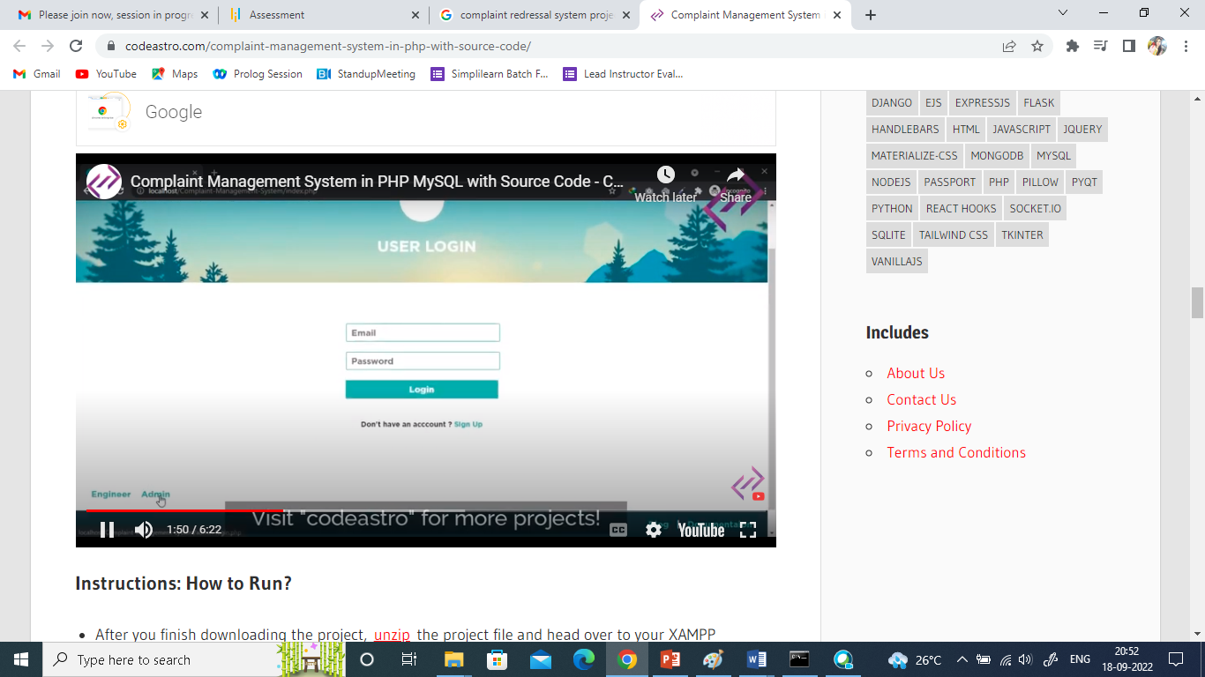

Here need to provide two links one for Admin and one for Engineer Login

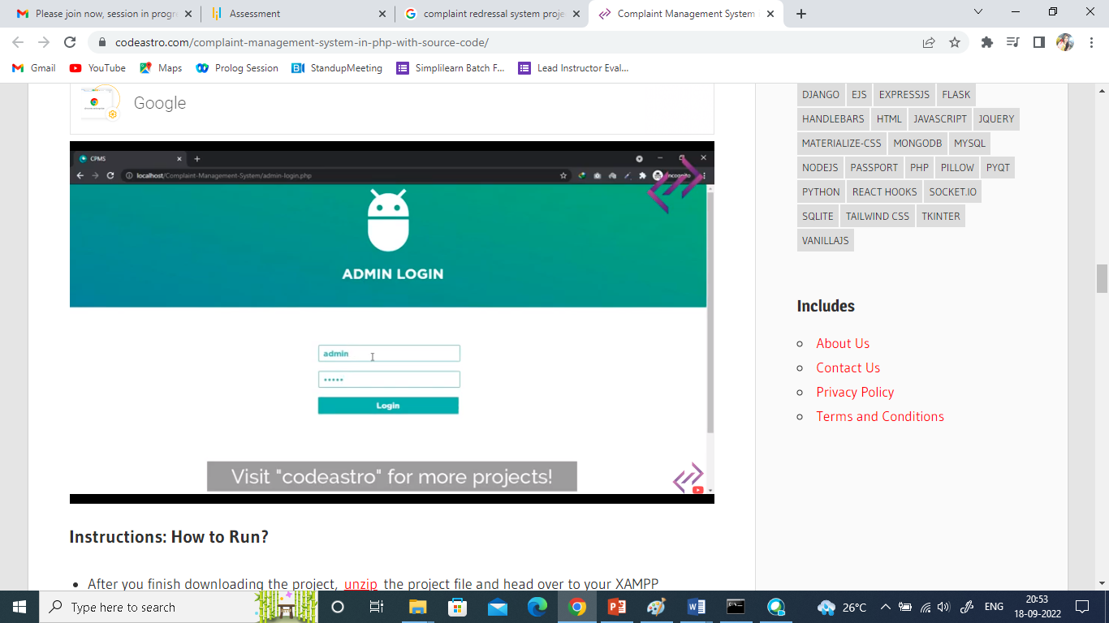

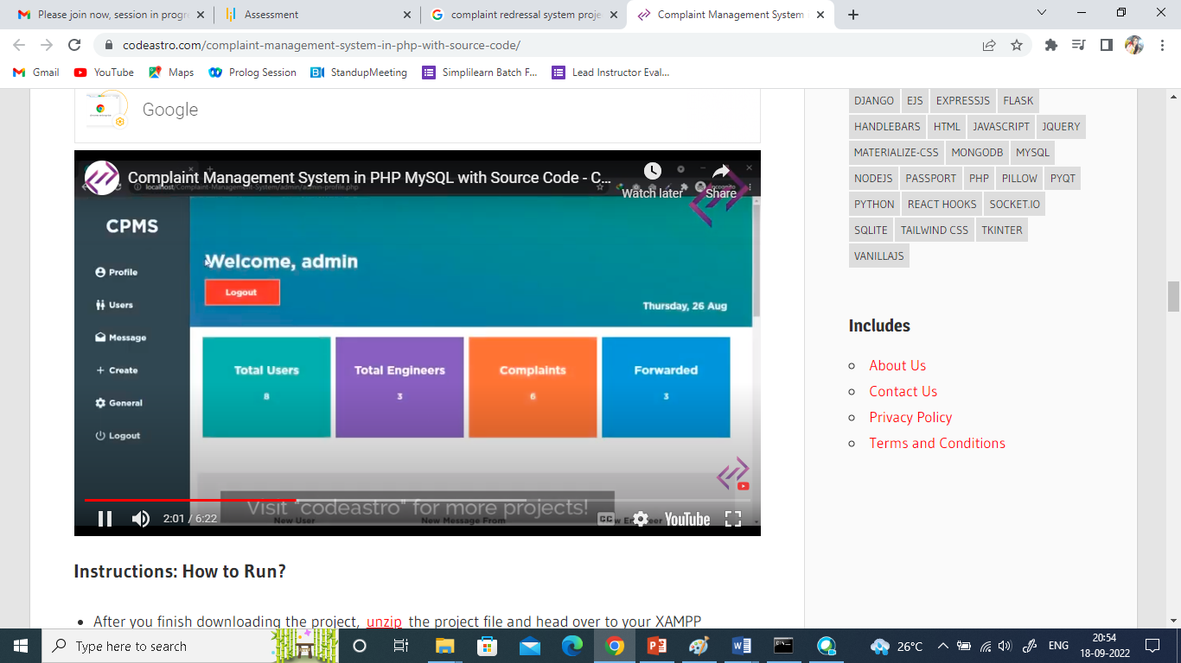

If you click on users show registerd Users

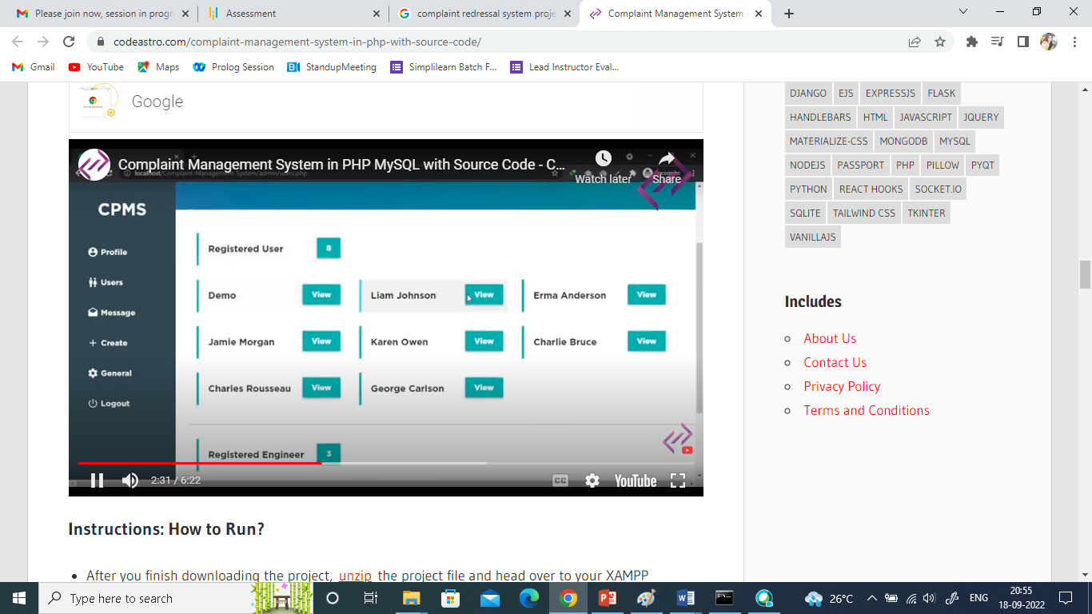

Click on user view button to see individual User Details

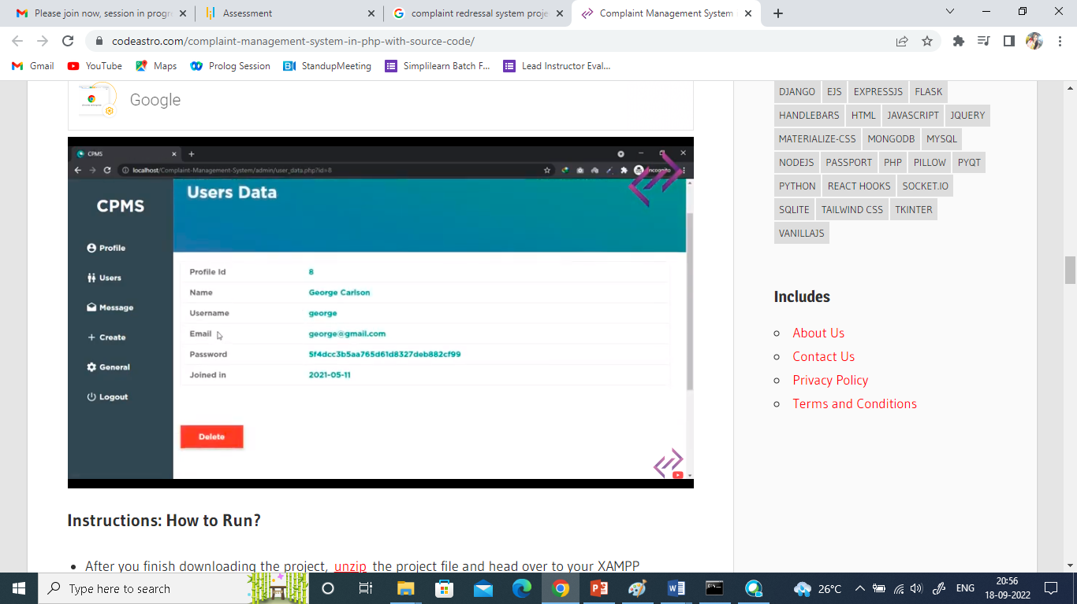

Click on delete to delete user if user is not valid.

Similary click on Messages to see complain and assign to complain to field engineer.

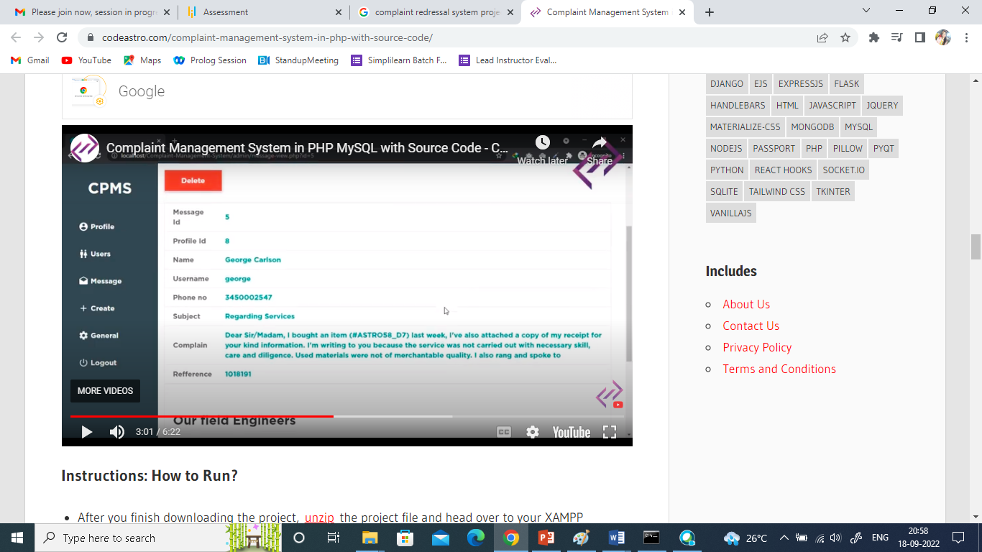

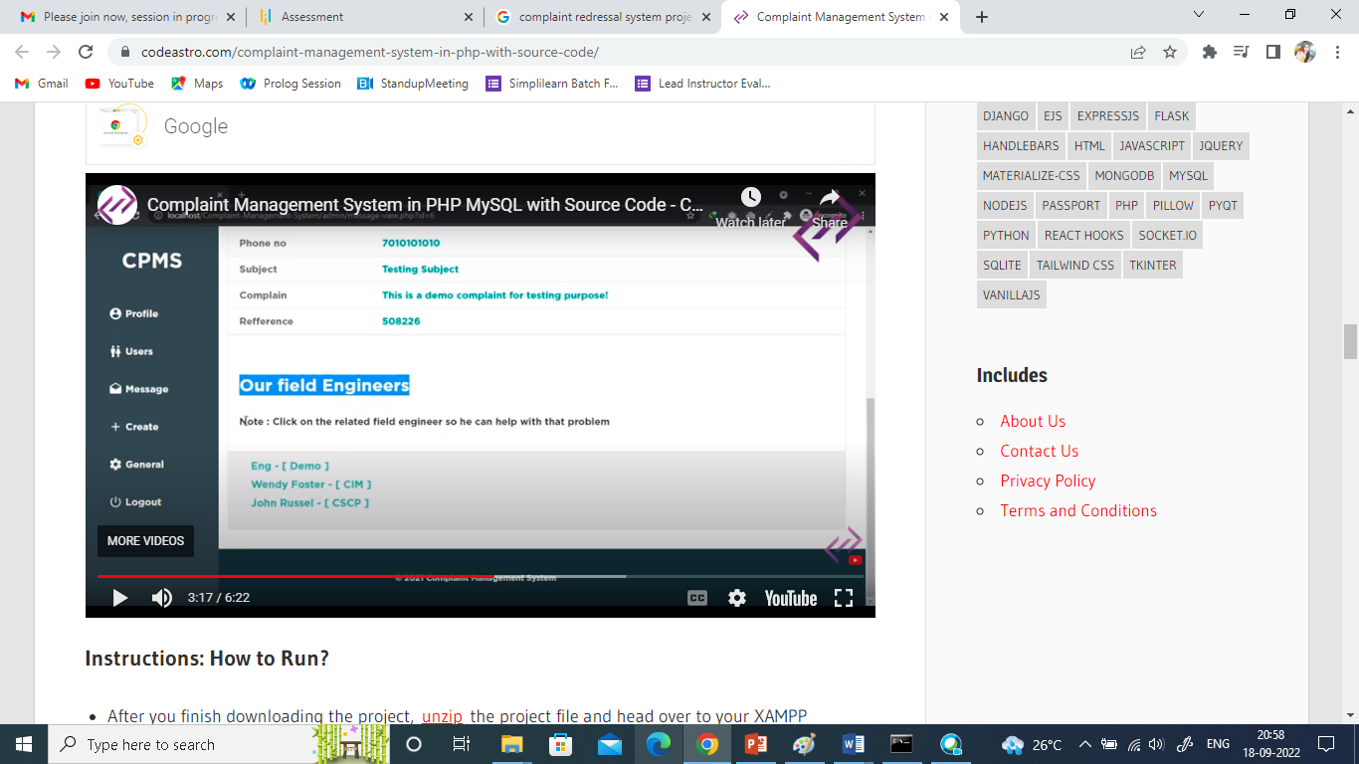

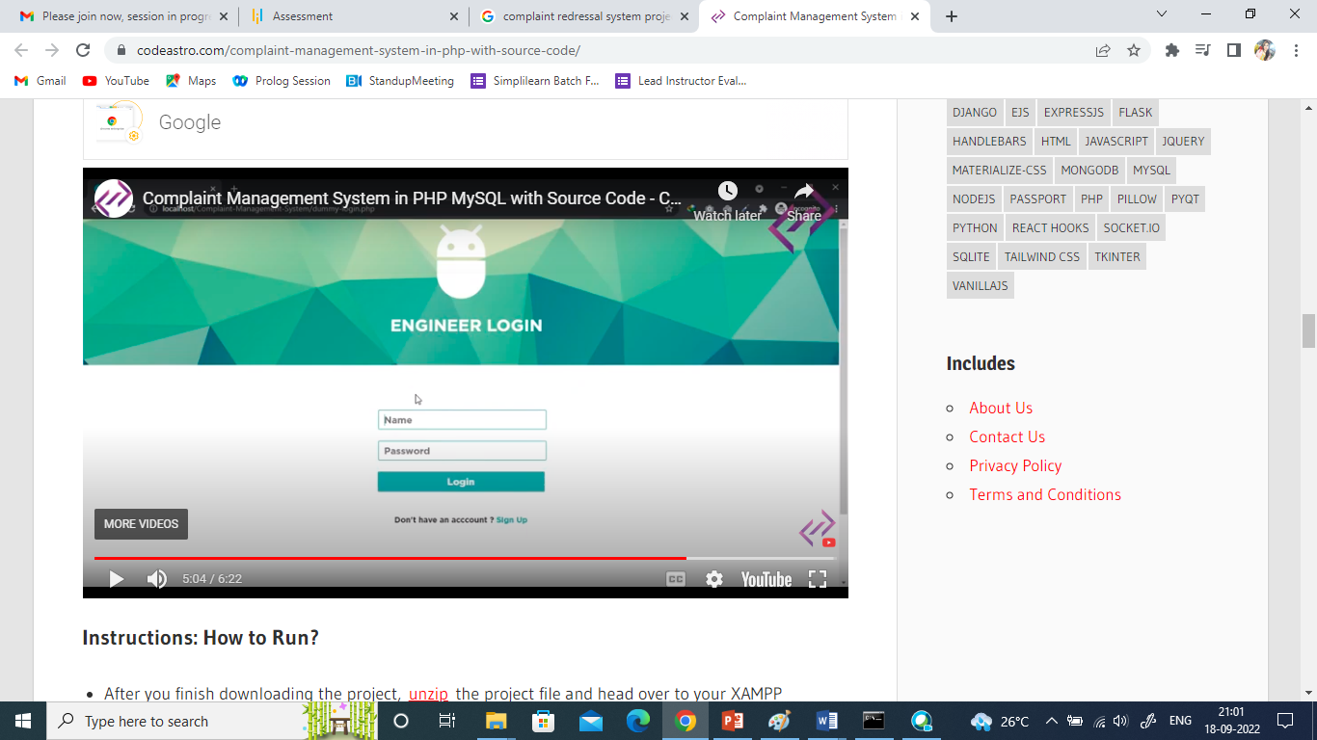

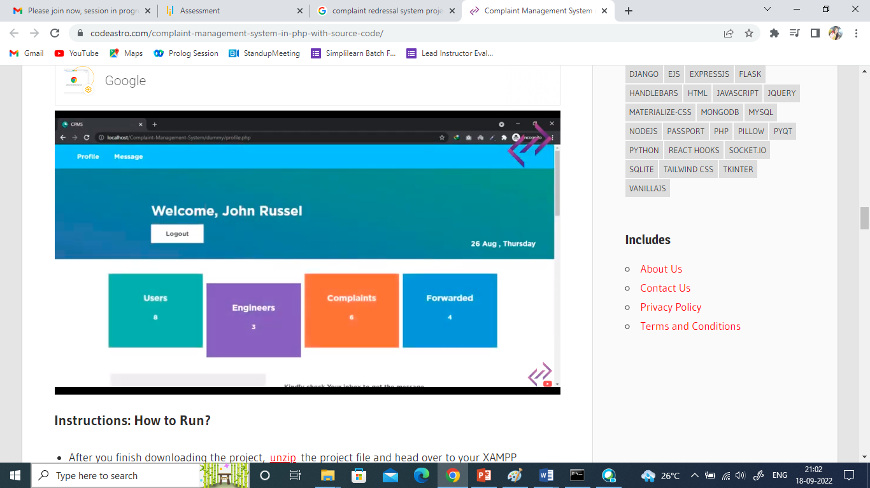

Engineer will update the status of the complaint.